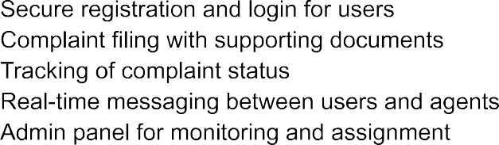

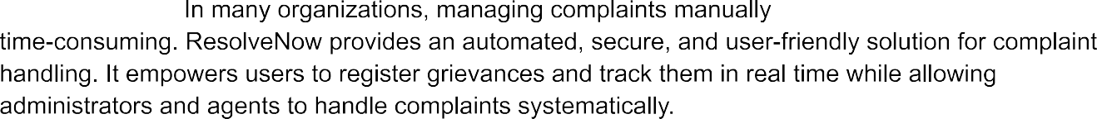



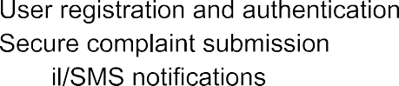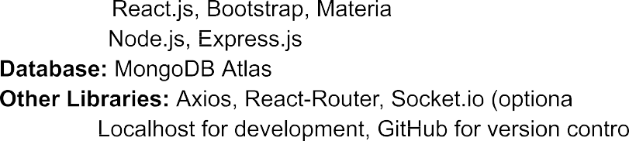

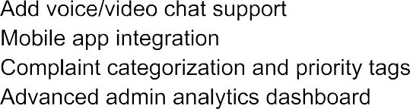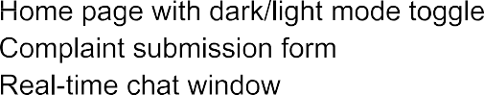

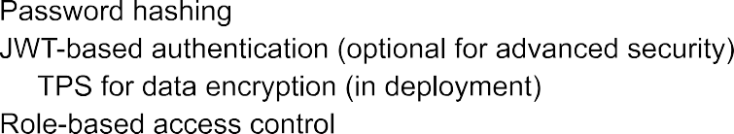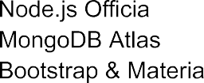







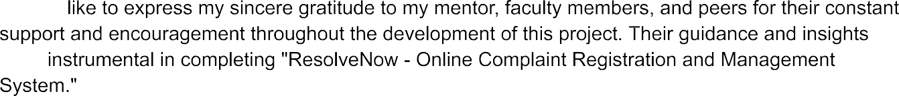

**Developer Name:**Chitoory Lalitha Sahithi

**Email**:chittoorysahithi@gmail.com

**GitHub Repository**: <https://github.com/Sahithichittoory/ResolveNow_Your-Platform-for-online-complaints.git>

Prepared by: Chitoory Lalitha Sahithi

Course/Department: B Tech ECE

Institution: Aditya College of Engineering & Technology

Date: 25/06/25